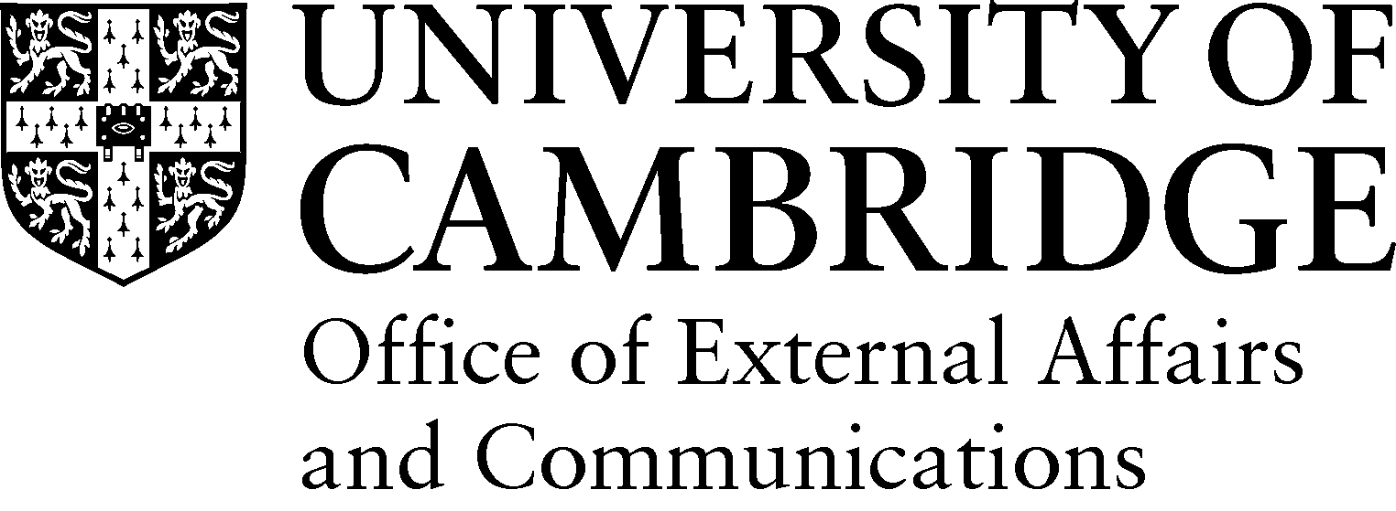

Public Engagement with Research: Spotlight on initiatives
This is a listing of larger public engagement initiatives based in departments, often with some dedicated resource, as well as museums at the University, which engage the public with research. [First draft: January 2015]

Across the University

Cambridge Festival of Ideas | The Festival of Ideas offers over 200 free events for all ages, providing a window into the arts, humanities and social sciences and takes place each October.
Cambridge Science Festival | The UK’s largest free science festival giving families, adults and children an insight into the University’s cutting edge research. The festival consists of over 200 events and activities over a two week period in March each year.
Naked Scientists | The Naked Scientists are a media-savvy group of physicians and researchers who use radio, live lectures, and the Internet to strip science down to its bare essentials, and promote it to the general public. Their award winning BBC weekly radio programme, The Naked Scientists, reaches a potential audience of 6 million listeners across the east of England, and also has an international following on the web.

Museums and Collections
Cambridge University Botanic Garden | The Botanic Garden welcomes over 200,000 visitors a year and incorporates a programme for lifelong learning including formal and informal learning courses, educational visits, and community arts activities in order to showcase a range of global habitats and the plants adapted to them.
Fitzwilliam Museum | The Fitzwilliam Museum is the principal museum of the University of Cambridge. The museum runs a programme of activities for adults, families and children including lectures and introductory tours. It also offers training and pre-familiarisation visits for teachers.
Kettle's Yard | Kettle's Yard house a gallery celebrates the best of visual arts and music. The education programme aims to extend understanding and enjoyment of contemporary and 20th century art through after-schools clubs, adult drawing sessions, and community partnerships with Alzheimer’s and homeless charities.
Museum of Archaeology and Anthropology | Displaying renowned archaeological and anthropological collections from around the world the museum offers a programme of public events and workshops alongside educational visits and resources for schools.
Museum of Classical Archaeology | Housing plaster casts of the most famous statues from ancient Greece and Rome, the museum’s education service offers tailored sessions for schools, families and children throughout the year.
Museum of Zoology | Showcasing an extensive collection of scientifically important zoological material and the museum offers public discovery talks, guided tours and educational resources for schools and colleges.
Scott Polar Research Institute Museum | A collection of artefacts, paintings, drawings, photographs telling the story of life in the Polar Regions. The museum runs a series of public events, school workshops and guided tours.
Sedgwick Museum of Earth Sciences | The museum is home to fossils, rocks and minerals from around the world covering 550 million years of Earth's history. The museum offers an extensive selection family activities and public events, as well as dedicated sessions for schools and supporting educational resources.
University Library | The Exhibition centre at the University Library hosts a number of fascinating free public exhibitions each year.
Whipple Museum of the History of Science | The Whipple Museum is a world-class collection of scientific instruments, covering all branches of science and its applications, from the 16th century to the modern day. The museum encourages school groups visits, and staff have given talks in local primary schools.

Schools and Departments

Arts and Humanities
Classics | Cambridge School Classics Project provides online classics resources for teachers. The Greeks, the Romans and us website offers information and events for school students interested in studying classics.
History | Cambridge History for Schools provides hands-on workshops for Key Stage 3 and 4 students designed to stimulate a passion for history and encourage a critical discourse around evidence and interpretation.
Music | Cambridge Music Education Outreach offer a programme of activities targeted at primary and secondary schools including Cambridge Young Composer of the Year, taster days and summer schools. The team also oversees community projects with prisons, hospitals and care homes.
Architecture | The Madanya Education Project aims at providing access to computing resources as creative let-out for children in India and Kenya. It is supported by local NGOs and schools, the Raspberry Pi Foundation and the EcoHouse Initiative.

Humanities and Social Sciences
Archaeology | Access Cambridge Archaeology offer discovery days, field academies, classroom activities and information and advice about Archaeology at Cambridge.
Politics and International Studies | ELECTION is a weekly politics podcast, started in 2015, which includes a live recording with a school student audience.

Biological Sciences
Plant Sciences | Science and Plants for Schools supports secondary and post-16 science teachers by providing teaching resources, e-newsletters, grants and an advice line. The aim is to ensure plant science teaching is contemporary, relevant and accurate on subjects such as climate change, energy sources, food security and new medicines.
Sainsbury Laboratory | The Sainsbury Laboratory runs outreach events throughout the year, including a subset targeted at secondary school students and teachers.
The Gurdon Institute | Gurdon Institute Outreach flagship activity is the ‘The Mobile Lab’ which takes hands-on microscope activities into primary schools. The Institute also holds open days for the public and schools and organises a series of seminars and workshops for core staff and local teachers.
Stem Cell Institute | The Institute offers a programme of public events as well as research experience placements for sixth form students.

Clinical Medicine
Cambridge Institute for Medical Research | The Institute contributes to a series of public events and festivals, as well as running patient support workshops and school visits.

Physical Sciences
Astronomy | The Institute offers a selection of open evenings which include a public lecture and live star gazing (weather permitting) alongside school visits, work experience and targeted sessions for brownies and scouts.
Physics | The Cavendish Laboratory has an extensive outreach programme for physics teachers and students aged 11-19 and physics teachers. This programme includes  - Isaacphysics.org – a national, department for education, funded initiative to bridge the gap between school and university.  - Physics at Work – an interactive exhibition of current research in academia and industry  - Cambridge Colleges’ Physics Experience - a collaborative initiative between the colleges and the department for Y9, 11 and 12 students  - Museum tours for schools  - Work experience placements for students aged 16+  - Cambridge Physics Centre Lecture Series  In addition, many research groups organise smaller events, such as the annual High Energy Physics Masterclass., astronomy events and visits to biological and other laboratories.
Mathematics | The Millennium Mathematics Project is a maths education and outreach initiative for students aged 3 – 19 and the general public. Formed as a collaboration between the faculties of Mathematics and Education the project consists of a family of complementary programmes including: NRICH, Plus, Hands-On Maths Roadshow, Enigma Schools Project, STIMULUS and public lectures.
Earth Sciences | The Templeton-funded 'Map of Life' project is specifically aimed at communication with society at large. Specialist science writers have been employed for this ambitious public outreach activity which has generated two substantial web resources Map of Life, 42evolution (http://www.mapoflife.org/ and http://www.42evolution.org/ )  “Time Truck” is a student run voluntary organisation which is designed to take Earth Sciences into the classroom at primary school level. Each year, a half tonne truck is hired and filled with interactive, hands-on Earth Sciences exhibits and posters, which are taken to local primary schools around Cambridgeshire during National Science Week. Our volunteers work with children aged 7-11 in a fun environment, with the aim of sharing our enthusiasm for earth sciences and introducing them to some basic scientific principles. The Time Truck has been operating for over 10 years and is also involved with a number of Open Days including the Geologist's Association's `Rockwatch' event http://www.rockwatch.org.uk/ and the Cambridge Science Festival.  The Sedgwick Museum is an integral part of the Department of Earth Sciences and is the main outlet for outreach activities. It attracts over 90,000 visitors per year and is a popular destination for school and community groups. Dedicated display space is used to showcase the Department's research and PIs regularly include funding to support this in research grant applications.  We participate annually in Cambridge Open Days which invite prospective students currently in Year 12 to tour the Department and attend presentations. We also contribute to the Cambridge Science Festival, which attracts over 90,000 visitors, receives national media coverage and is a high-profile opportunity to engage the public in our research.  Other outreach visits to schools are reactive – if a request is received for someone to speak in a school, we can usually find a volunteer. There are typically 5-6 school visits/year and these may be carried out by graduate students, postdocs or academic staff.  One of our senior academics has recently spent several months in 2014 seconded to the BBC as a British Science Association Media Fellow http://blogs.egu.eu/geolog/tag/bbc-media-fellowship/. Our staff work regularly with the 'The Naked Scientists', who produce science podcasts and an internet science radio show; their programmes reach multi-million audiences per week, and their pod-casts are downloaded typically 600,000 times a month. They frequently speak at events such as the Hay Festival and of course regularly present their science through television, radio, and newspaper interviews. Several have written popular articles and books.  In 2014 we produced a professional promotional video (featuring our students and David Attenborough), this was targeted at all incoming students reading Natural Sciences at Cambridge but has gained a much wider audience, the Youtube trailer has 14,000 hits: https://www.youtube.com/watch?v=i6aIBhMMyNc and the full 13 min film has received 8,000 hits.
Materials Science | The Department hosts a range of educational events including half-day masterclasses for secondary students and week-long residential courses for sixth form students. Events are held in partnership with bodies such as The Goldsmiths company and the EDT Headstart scheme.

Technology
Engineering | The Department runs an outreach programme to introduce school children to the excitement of engineering in a university research environment. They also provide educational resources for parents and teachers.
Computer Science | The Laboratory participates in a wide range of outreach activities with schools, colleges and communities including Sonic Pi workshops.

Activities led by students, research students, post-doctoral researchers etc
CHaOS | Cambridge Hands-On Science (CHaOS) is a voluntary student group based in Cambridge that believes science is fun and relevant to all. The group organises a hands-on science tour of the UK and take part in festivals and activities throughout the year.
Pint of Science | This annual international festival takes place in May each year with the aim of delivering interesting, fun, relevant talks on the latest science research in an accessible format to the public - all in the pub! Pint of Science is a non-profit organisation.
Bright Club | A regular comedy night where academics get behind the mic and entertain audiences about their research. Originating in London, there are now Bright Club branches across the UK. The branch in Cambridge is held at the Portland Arms.

