University of Cambridge
VERY shorts 2020
Project brief
Cambridge very shorts is a novel research illustration competition. It builds up on the successes of Cambridge shorts but it is the first of its kind. The role of the visual artist is to convert University of Cambridge research into an illustrated gif animation.

Objective for illustrators/animators
Develop a gif animation based on current research by University of Cambridge academics.
Timeline
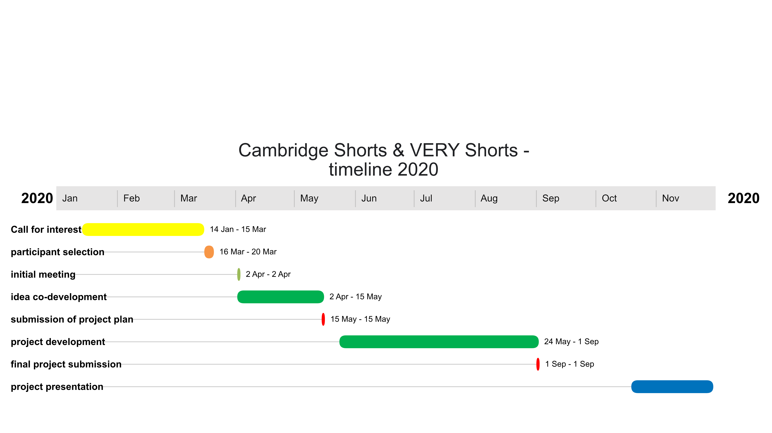
Key dates for creatives working on VERY Shorts:
15 March | Application deadline for researchers and creatives
20 March | Shortlisted candidates will be contacted
2 April | 3 to 5 pm, first informal meeting in Cambridge, pairing between researchers and creatives
2 April – 15 May | Co-development of project idea between researcher and creative
15 May | Submission deadline for project ideas to project coordinators, this will be followed by a project meeting (can be vial phone)
May to September 2021 | Creation of final animation
1 September | Deadline for project submission
October 2020 – March 2021 | Project presentations during Cambridge festivals and online

Expectations of time needed
We estimate a time commitment of 2-4 days for creatives. This includes 2 h for the initial meeting, time to co-develop the project idea in close collaboration with the researcher, and time to illustrate and present the final animation. While attendance in person during the initial meeting on 15 March is required, the co-development and mid-project meeting (after the 15 May) can be arrange as video calls.
Budget
We except project proposals for up to £1000 (submitted by 15 May). This should include your time, materials and necessary travel expenses to Cambridge.

