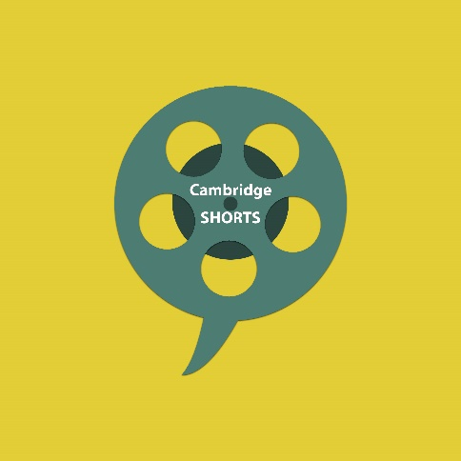
University of Cambridge
Shorts 2020
Project brief
The popular research film competition is back. Cambridge Shorts is the continuation of a project to support early career researchers in developing professional short films with filmmakers. The short films will be presented online and during the Cambridge Festivals to increase the visibility of your work. The role of the filmmaker is to convert research from the University of Cambridge into a short film (max 2 minutes).

Objective for creatives:
Develop a short film based on current research by Cambridge Academics. This can be a creative piece of work, we are not looking for traditional interview based research documentaries.
Timeline
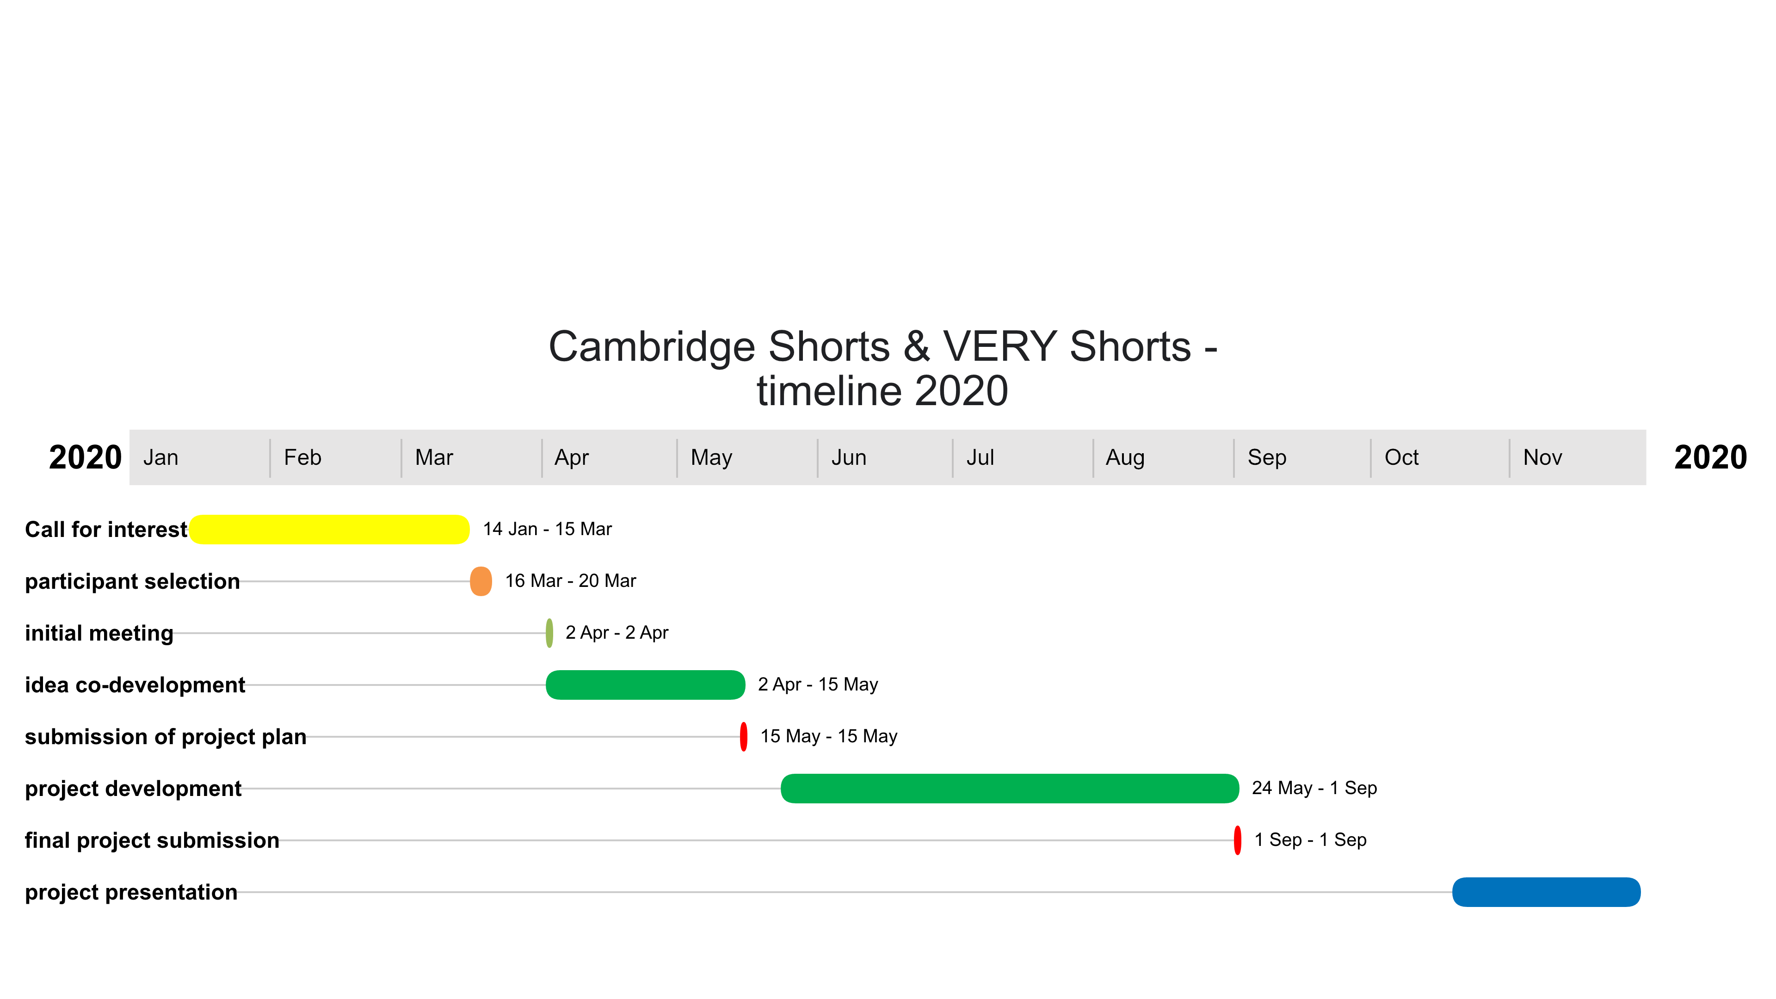
15 March | Application deadline for researchers and filmmakers
By 20 March | Shortlisted candidates will be contacted
2 April | 3 to 5 pm, first informal meeting in Cambridge, pairing between researchers and creatives
2 April – 15 May | Co-development of project idea between researcher and creative
15 May | Submission deadline for project ideas and final budgets to project coordinators, this will be followed by a project meeting (can be vial conference call)
May to September 2021 | Creation of final short film
1 September | Deadline for film submission
October 2020 – March 2021 | Project presentations during Cambridge festivals and online

Expectations of time needed
We estimate a time commitment of 2-4 days for creatives. This includes time for meetings, time to co-develop the project idea in close collaboration with the researcher, and time to shoot and edit the final short film. While attendance in person during the initial meeting on 15 March is required, the co-development with the researcher and a mid-project meeting (after the 15 May) can be arrange as video calls.
Budget
We except project proposals for up to £2000 (submitted by 15 May). This should include your time, materials and necessary travel expenses to Cambridge.

