Public Engagement Creative Projects Call 2020
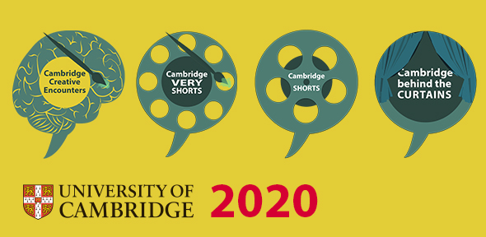
The following 4 Public Engagement calls are now open for applications to University of Cambridge early career (PhD, postdocs) and established researchers. Applications can be submitted by individuals or groups and can be made to one or more of the following projects:

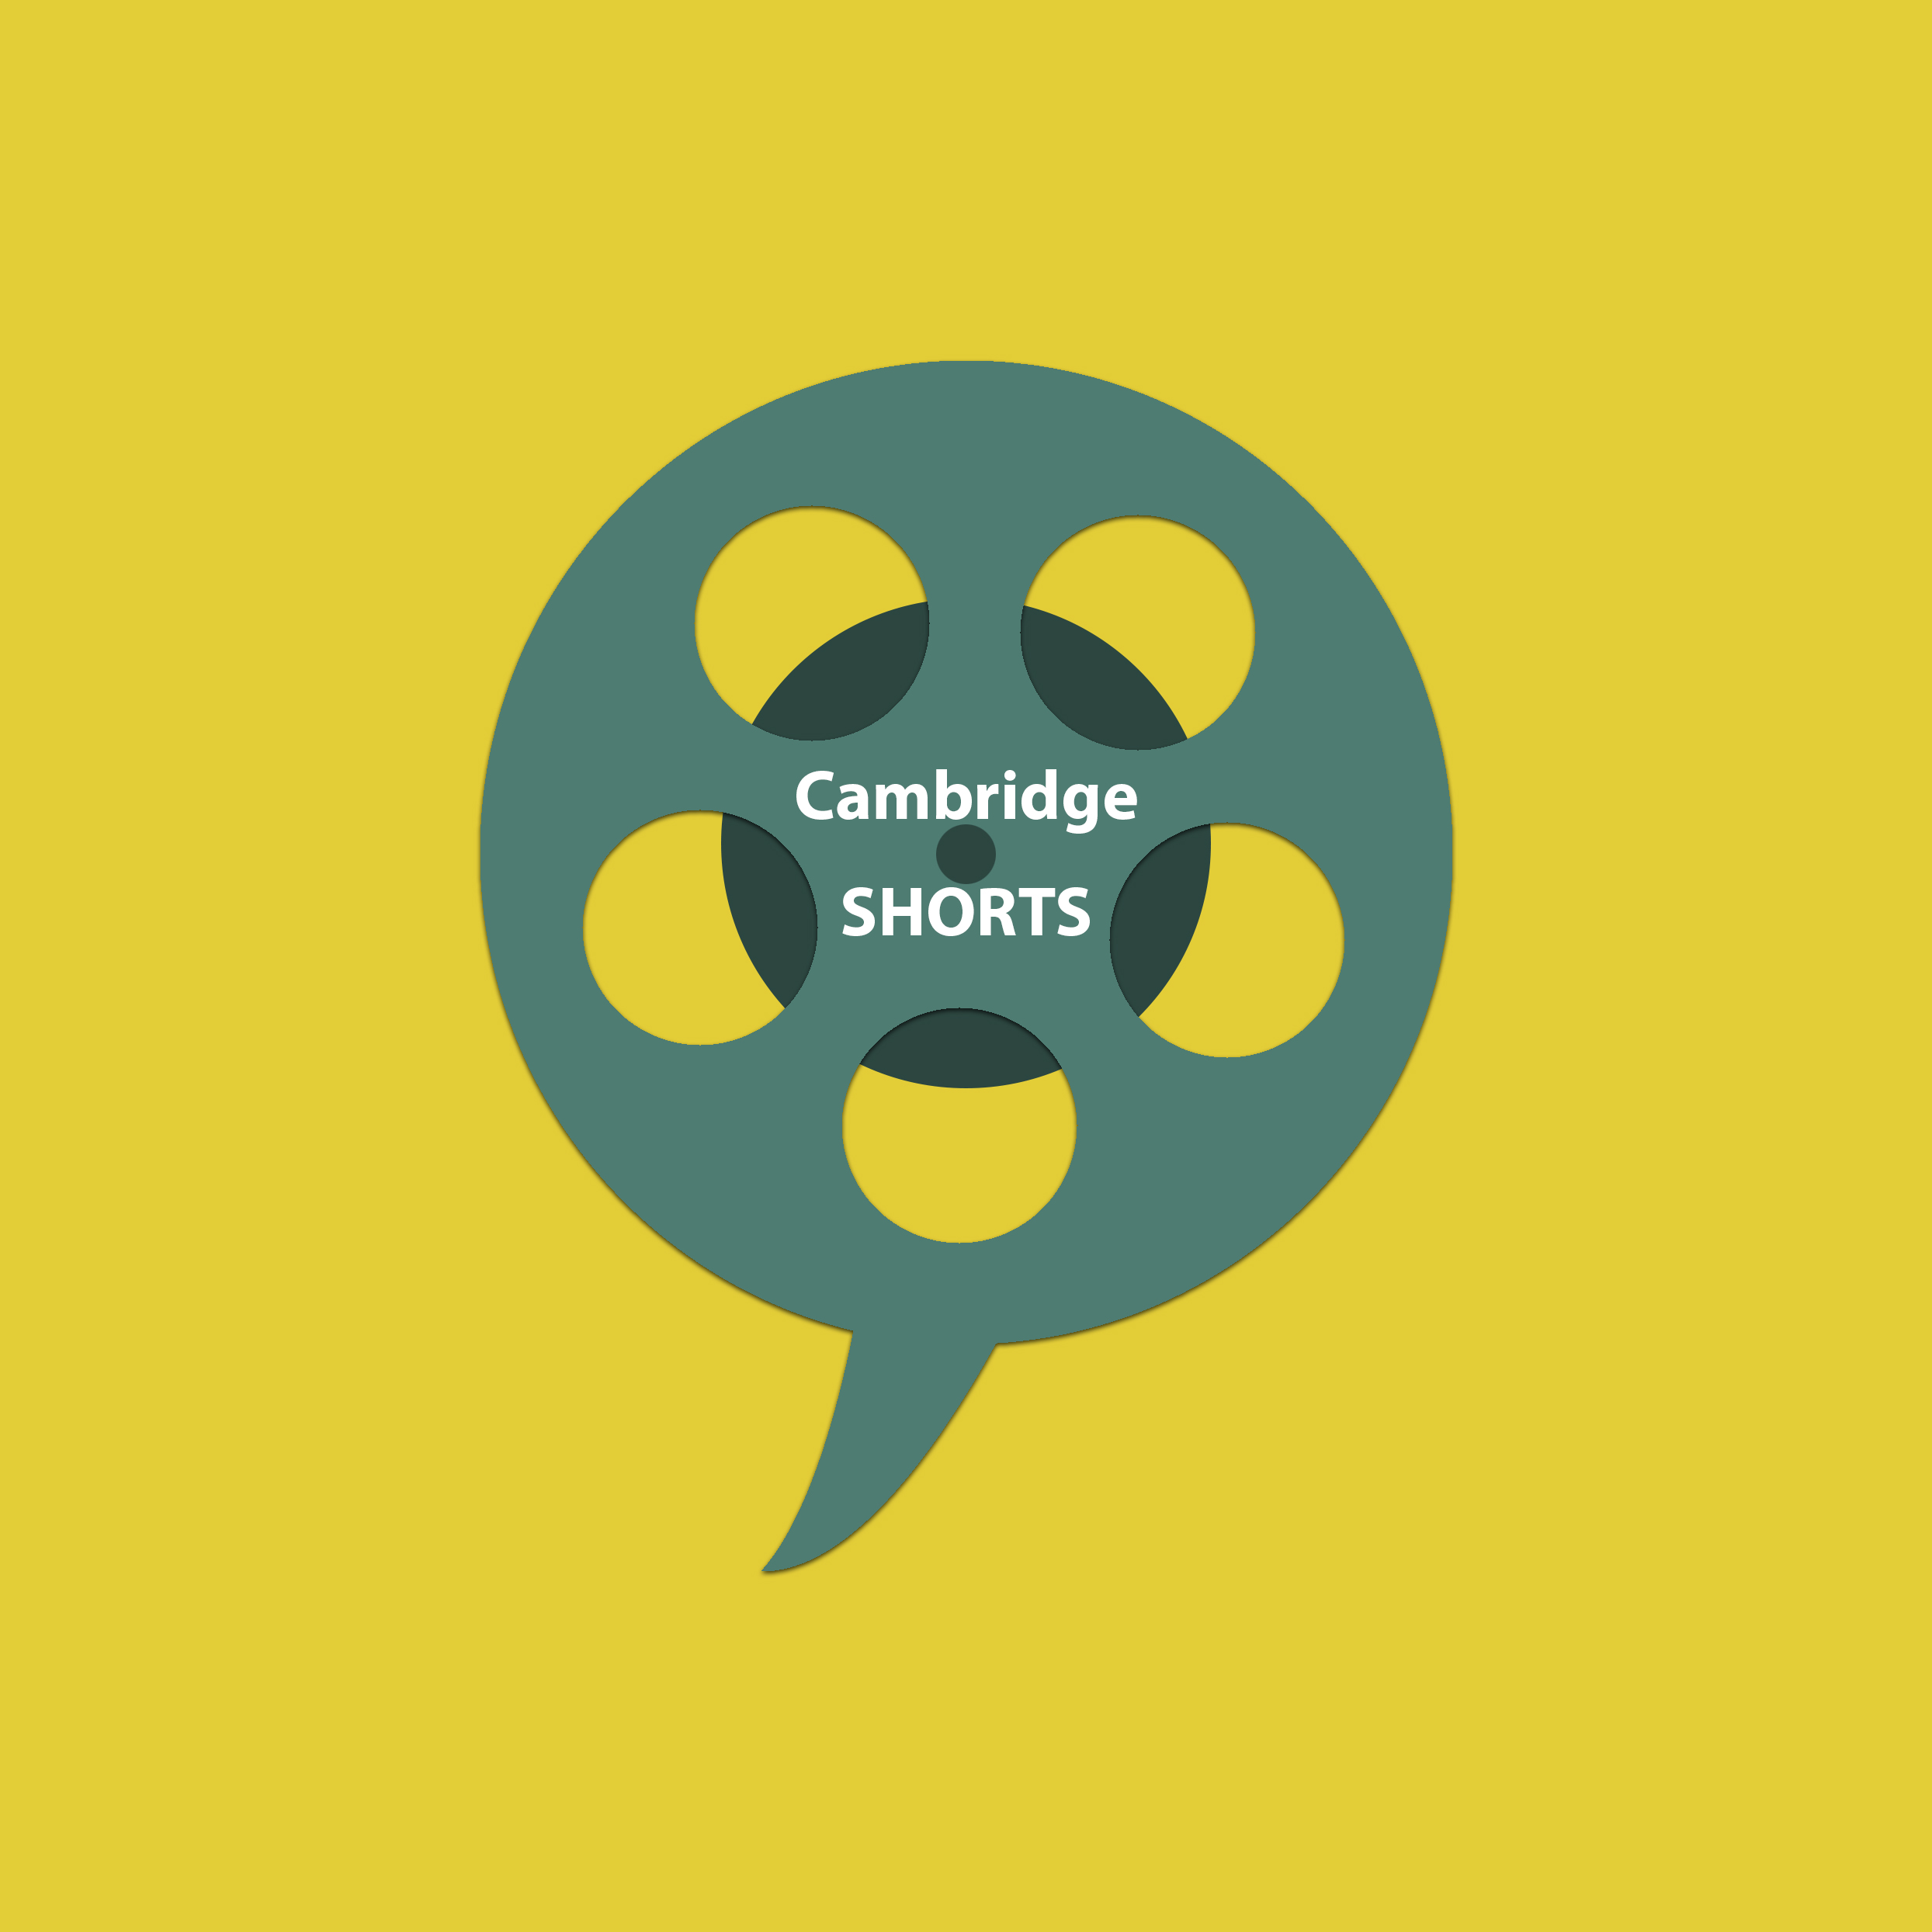Cambridge Shorts
The popular research film competition is back. Cambridge Shorts is the continuation of a project to support early career researchers in making professional quality short films with filmmakers. The short films will be presented online and during the Cambridge Festivals to increase the visibility of your work.

Cambridge Very Shorts
Turn your research story into an illustration or animated GIF. Cambridge Very Shorts allows you to collaborate with a creative to develop your visualisation. Visualisations will be tied into a communication plan to increase the reach and distribution of your work and presented as part of the festivals.

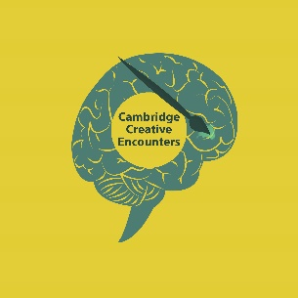
Creative Partnerships
Creative partnerships is enabling collaborations between researchers and media students from a local further educational college. You will be paired with students to produce a creative piece of work based on your research. The creative outputs can be films, video games, animations, or podcasts among others.

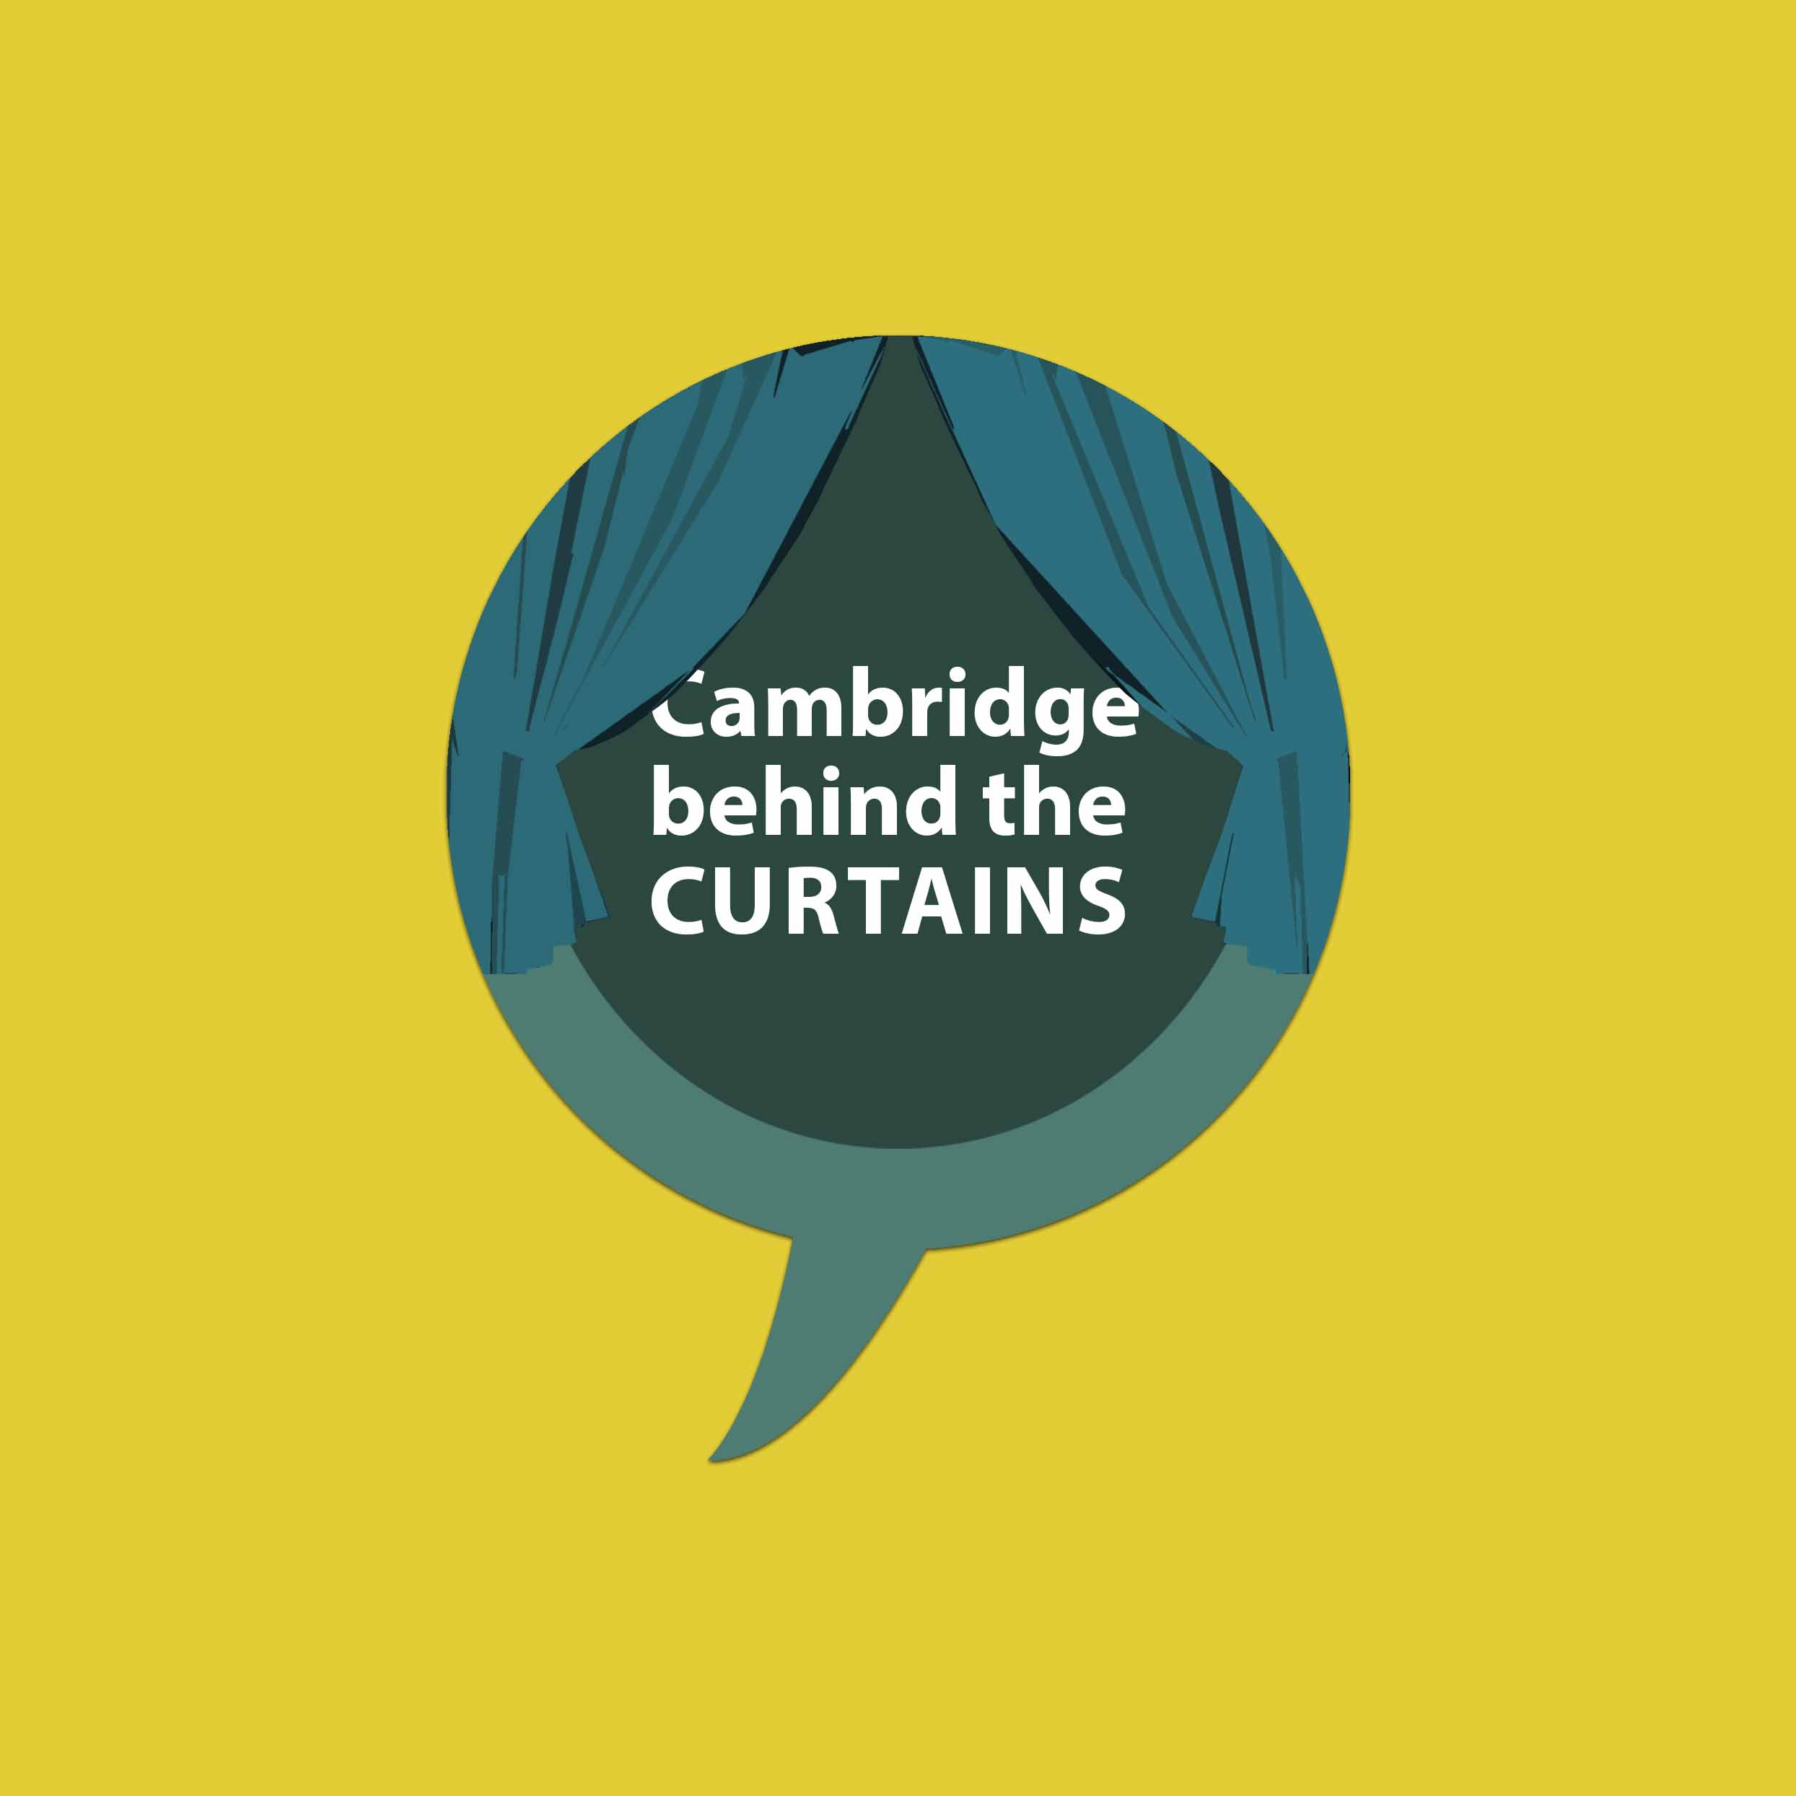Cambridge behind the Curtains
Have you ever imagined how your research might look and sound on stage? This is your opportunity to explore the world of theatre playwriting together with professionals. Selected applicants will work with Menagerie Theatre Company to turn their research into a play. One participant will have the exclusive opportunity to get a funded place in a workshop for young writers with the chance to see their writing performed before an audience during 'The Hotbed Theatre Festival'.

Creative Encounters

Application Form – Researcher

Application Guidance: Please fill in all sections of the application form below. The document should be submitted as a word file named as” CP_researcher_ SURNAME.docx” to alina.loth@admin.cam.ac.uk AND dam74@medschl.cam.ac.uk

Please note that that all participants have to take part in an initial meeting with the creatives (2 April for Cambridge Shorts & VERY Shorts, 22 April for Creative Encounters) or a training workshop (6 March for behind the Curtains) in Cambridge. Please only apply for a project if you can attend the initial meeting/training and will be able to commit time to the co-development process with the creative. You can apply to one or all four projects. While you might only get shortlisted to one, please only apply for more than one if you will be able to participate.

The final deadline for applications is 15 March 2020. Selected applicants will be contacted by 20 March.

- Please indicate which of the projects you want to apply for?
Note: You can apply to one or all three

☐ | Cambridge Shorts | Initial meeting: 2 April 2020, 3 to 5 pm
☐ | Cambridge VERY Shorts | Initial meeting: 2 April 2020, 3 to 5 pm
☐ | Cambridge Creative Partnerships | Initial meeting: 22 April 2020, 10 am to 12 noon
☐ | Cambridge behind the Curtains | Initial workshop: 25 March, 10 am to 1 pm
☐ | I will be able to attend the initial meeting

- Applicant details

Name:
(note: this will be the main contact for the project)

Academic school | ☐ Arts and Humanities  ☐Humanities and Social Sciences  ☐ Biological Sciences  ☐ Physical Sciences  ☐ Clinical Medicine  ☐ Technology  ☐ independent of schools, please specify:
Faculty/department

Contact Email
Contact phone number
Job title
(e.g. PhD student, post-doc…)
If you apply as a group, please list names and contact emails of additional project members here

- Project
Please briefly describe the research content you want to collaborate on (max 300 words)
Please briefly describe why you want to take part (max 200 words)

If applicable, you can add any pictures or web links in support of your application here or in one separate pdf file:

